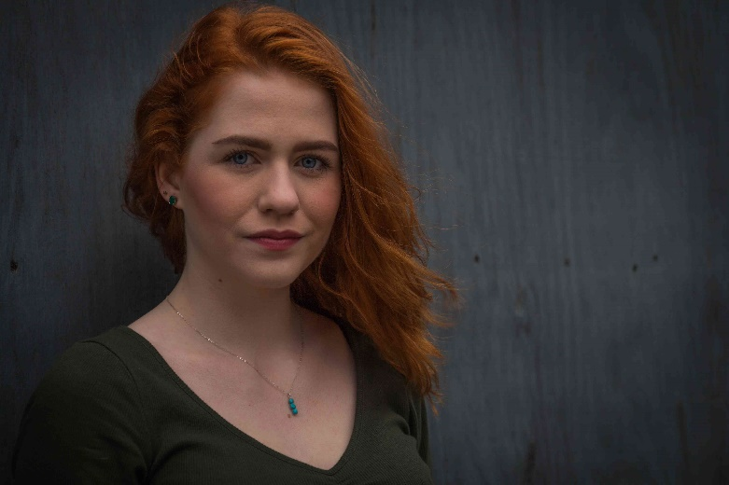
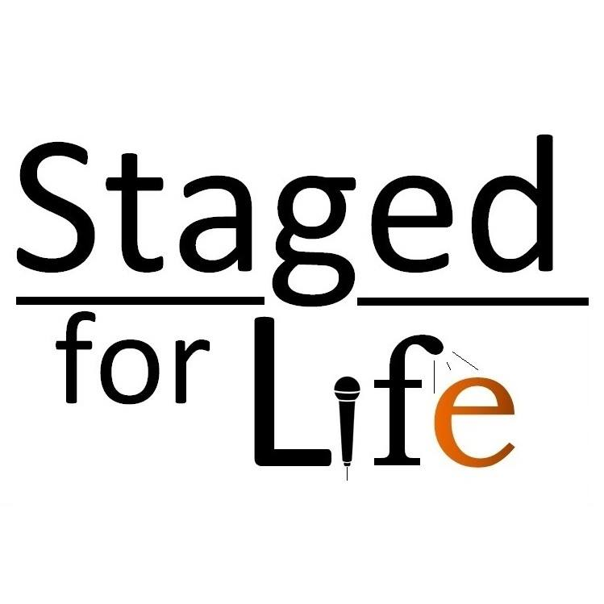

CASE STUDIES: EMMA HARLEY, STAGE MANAGER
WINTER COURSE, FEBRUARY 2018
I had found myself in a bit of a rut, in a job that no longer interested me and unable to get professional work in a different area of theatre because most of my experience came from self-made work. I saw Staged for Life as a welcome chance to learn new skills and break the monotony of what I was doing, whilst hopefully increasing my employability.
“this training has made me far more employable as someone with a broad skills base”
Since completing the course, I have continued to make my own theatre, and have been able to introduce more complex uses of sound, enriching the work and broadening my views of what I am able to create. Currently I am employed as a stage manager for Bard in the Botanics' productions of Antony and Cleopatra and Edward II, and will be going straight into employment as a venue technician for the Edinburgh Fringe.
Staged for Life gave me a technical foundation, without which I would not be qualified for my current employment. I could operate basic tech before, but I know now how to set up lighting and sound elements and how to troubleshoot to find the source of any issues. I had already been a stage manager in the past, but this training has made me far more employable as someone with a broad skills base.
“be yourself, and be hardworking and enthusiastic”
If someone was thinking about applying for the course, I’d tell them to be honest about what you want from the course, be yourself, and be hardworking and enthusiastic. It's a fairly short course so go in with the attitude of making the most of it.

CASE STUDIES: JAMES MARSH, A.V. TECHNICIAN
SUMMER COURSE, JULY 2016
Staged for Life gave me the skills I needed to build up a career in AV technology. I come from a videography and media background, and as an anxious person, I thought I never wanted to work in live events. As someone who was never involved with drama or anything of the sort, it took me quite by surprise, but I love my work and wouldn’t trade it for the world.
I did a placement with Paradise Green just after the Staged for Life course, which was originally going to be 1 week - I ended up doing 3, because I had so much fun. It will be my third year returning to Paradise Green in 2018. In November 2016, just after my course, I had my first tech job touring with Black Dingo Productions.
“I love my work and wouldn’t trade it for the world”
“I made lifelong friends, I developed transferable skills, and it set me up on my career path”
In January 2017, I was lucky enough to get a job at Dynamic Earth as an AV technician, where I am still employed. I run the tech for conferences, dinners and other corporate events, and make sure the tech in the galleries is running smoothly, along with the team of 3 other technicians. In September 2017, the Annexe Arts Hub was founded, with myself and a few others forming the tech arm of the hub. The Formation festival in February had our techs running fit ups, and the Festival in July also had our techs operating shows, and doing get ins for shows - I was Technical Manager, making me responsible for the management of technicians, scheduling of fit ups, and the rota for the festival itself.

If you want to apply for Staged for Life, I would recommend you do. I made lifelong friends, I developed transferable skills, and it set me up on my career path. Regardless of if you have the skills now, or you have never touched a mixing desk and you want to learn, Staged for Life is a great place to start.

